**GOVERNMENT COLLEGE OF ENGINEERING ERODE**



B.E Electronics and Communication Engineering

**MEASURE ENERGY CONSUMPTION**

**Name of the Students: University Register no:**

**Team Leader:**

Anburaj.S 731121106103

**Team Members:**

Boopathiraj.V 731121106003

Dharaneeswaran.K 731121106008

Prabhakaran.S 731121106035

Thanush Vishal.S 731121106051

Anburaj.S 731121106103

Under the mentor of

**Dr.M.Poongothai**

**Department of Information Technology(IT)**

**Department of Electronics and Communication Engineering**

Government College of Engineering

Erode ,PO ,near Vasavi College,TamilNadu-638316,

Affiliated to Anna University ,Chennai.

**Arduino UNO R3:**

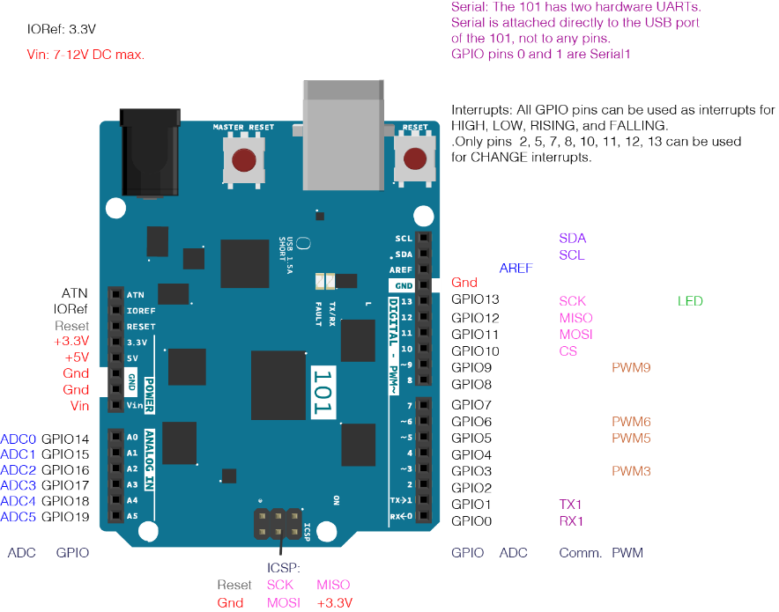

The Arduino UNO is the best board to get started with electronics and coding. If this is your first experience tinkering with the platform, the UNO is the most robust board you can start playing with. The UNO is the most used and documented board of the whole Arduino family.

**Main Features:**

Arduino UNO is a microcontroller board based on the **ATmega328P**. It has 14 digital input/output pins (of which 6 can be used as PWM outputs), 6 analog inputs, a 16 MHz ceramic resonator, a USB connection, a power jack, an ICSP header and a reset button. It contains everything needed to support the microcontroller; simply connect it to a computer with a USB cable or power it with a AC-to-DC adapter or battery to get started. You can tinker with your UNO without worrying too much about doing something wrong, worst case scenario you can replace the chip for a few dollars and start over again

**SPECIFICATIONS:**

### Uno R1 to R3

* [Microcontroller](https://en.wikipedia.org/wiki/Microcontroller) (MCU):
* [IC](https://en.wikipedia.org/wiki/Integrated_circuit): [Microchip](https://en.wikipedia.org/wiki/Microchip_Technology) [ATmega328P](https://en.wikipedia.org/wiki/ATmega328P) (8-bit [AVR](https://en.wikipedia.org/wiki/AVR_microcontrollers) core)
* [Clock Speed](https://en.wikipedia.org/wiki/Clock_rate): 16 [MHz](https://en.wikipedia.org/wiki/MHz) on Uno board, though IC is capable of 20 MHz maximum at 5 Volts
* [Flash Memory](https://en.wikipedia.org/wiki/Flash_Memory): 32 KB, of which 0.5 KB used by the [bootloader](https://en.wikipedia.org/wiki/Booting#Boot-loader)
* [SRAM](https://en.wikipedia.org/wiki/Static_random-access_memory): 2 KB
* [EEPROM](https://en.wikipedia.org/wiki/EEPROM): 1 KB
* [USART](https://en.wikipedia.org/wiki/USART) peripherals: 1 (Arduino software default configures USART as a 8N1 UART)
* [SPI](https://en.wikipedia.org/wiki/Serial_Peripheral_Interface) peripherals: 1
* [I²C](https://en.wikipedia.org/wiki/I%C2%B2C) peripherals: 1
* Operating [Voltage](https://en.wikipedia.org/wiki/Voltage): 5 Volts
* Digital I/O Pins: 14
* PWM Pins: 6 (Pin # 3, 5, 6, 9, 10 and 11)
* Analog Input Pins: 6
* DC Current per I/O Pin: 20 mA
* DC Current for 3.3V Pin: 50 Ma

**ARCHITECTURE:**

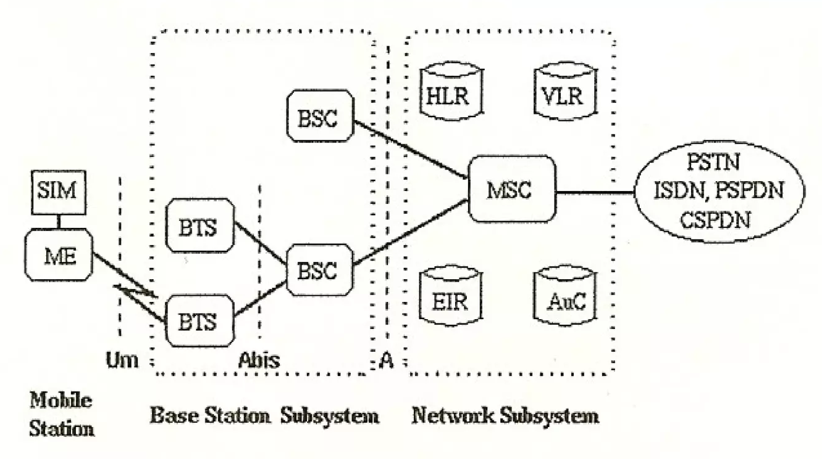

**GSM/GPRS Module:**

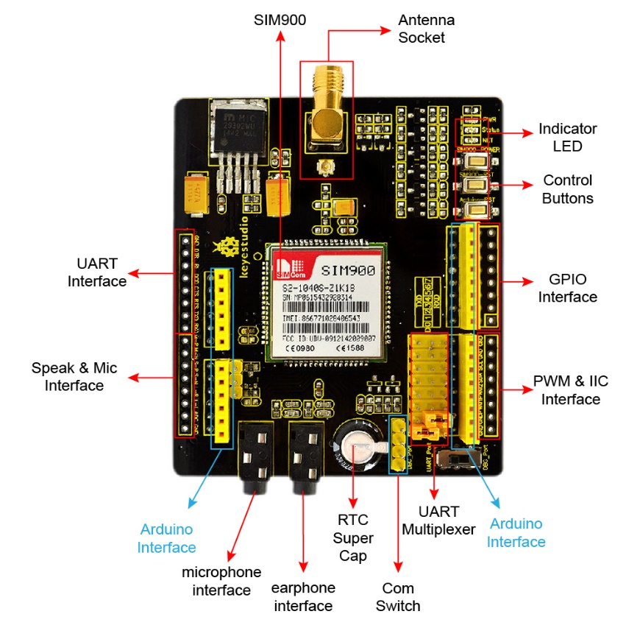

**I**

SIM900 GSM/GPRS shield is based on Quad-Band SIM900 GSM/GPRS module. It provides Arduino with GSM/GPRS function.  
This shield allows you to make voice calls, send SMS or make connections to the Internet network.  
On the shield, there is a serial port toggle switch for you to select either software serial port or hardware serial port to be connected to GPRS Shield.  
If you choose software serial port, you need to use the Software UART; otherwise, you need to use the Hardware UART.  
The shield includes a high capacitor dedicated to RTC (Real Time Clock).  
If you toggle the switch to DBG-Port, you can connect the port to Arduino or connect the port to PC by Arduino to proceed the debugging.

**SPECIFICATIONS:**

* 1. Auto-adaption to 3.3V and 5V main board, supporting 3.3V platforms such as leaf maple and Chip kit.
  2. After connecting the SIM900 shield to Arduino, 9V/2A DC power supply is needed. Otherwise, there might be malfunction.
  3. Quad-Band GSM/GPRS 850/900/1800/1900MHz (Support 2G card of UNICOM, China Mobile, do not support Telecom card).  
     We use SIM900 GSM Module – supporting communication in 900MHz band.  
     You should check the mobile network band in your area.

**SWITCHS:**

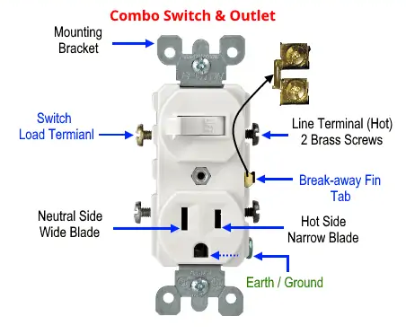 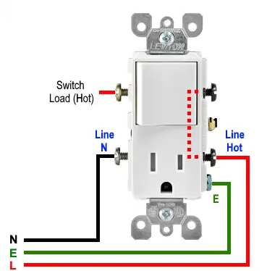

**1.Switch:**

A mechanical, electrical, or electronic device for opening or closing a circuit or for diverting a current from one part of a circuit to another

**2.Socket:**

 Sockets allow communication between two different processes on the same or different machines.